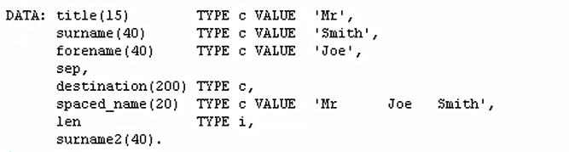

The first thing I'm doing is moving a value into the surname2 field. And this is Mr comma Joe Smith. Then, we're using the replace statement, and we're doing a replace the comma with a full stop into our surname2 field. And we'll write out the results.

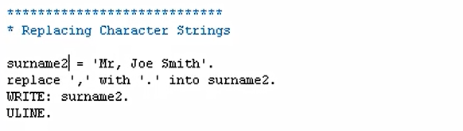

 First, let's pretty the code up. And then test it out. And there you can see, the output is Mr full stop Joe Smith. Now, one thing to note here is, with the replace statement, it will only replace the first occurrence in the string. And what I mean is, if our string had Mr comma Joe comma Smith, only the first comma would be replaced.

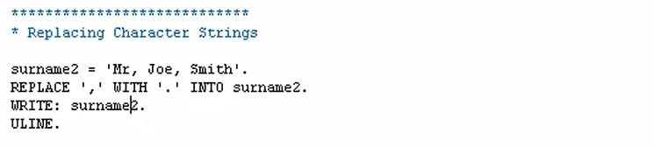

To show you that, let's test it out. And there, you can see. Only the first occurrence in the string has been replaced. So, how do you replace all the occurrences? Well, that's where we could use something we will come on to a little bit later on, when we have a look at loops. You could use a while loop so that our replace statement can be executed multiple times, dependent on a specific piece of logic that we add to our loop statement.

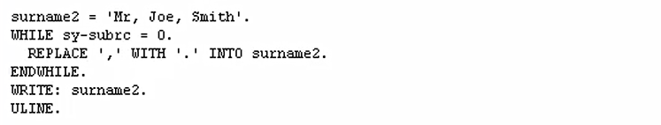



we can see the comma has been replaced in both positions within our text. And that's because the replace statement was executed two times.